**National University of Modern Languages,**

**Regional Campus, Hyderabad**

**Department of Computer Science**



**Name: Durr e shehwar**

**Batch: BSCS III**

**Practical no:4**

**Submitted to**

**Sir Rafay**

**Date:17-03-2023**

1. Simplify given expression using Standard Sum of Product, also show step by step process of building a circuit and designing a truth table.
2. F1(A,B,C) = A’B’C + BC’ + AC’

Simplifying by using SOP

= A’B’C + (A+A’)BC’ + AC’(B+B’)

= A’B’C + ABC’ + A’BC’ + ABC’ + AB’C’

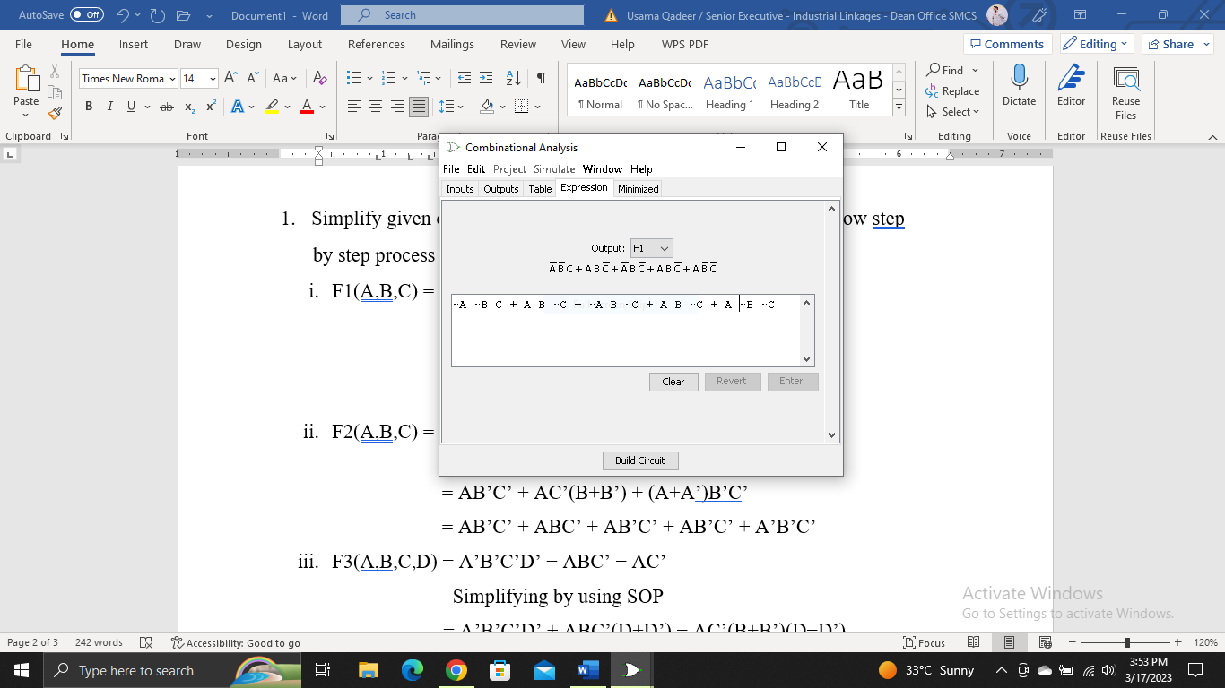

1. F2(A,B,C) = AB’C’ + AC’ + B’C’

Simplifying by using SOP

= AB’C’ + AC’(B+B’) + (A+A’)B’C’

= AB’C’ + ABC’ + AB’C’ + AB’C’ + A’B’C’

1. F3(A,B,C,D) = A’B’C’D’ + ABC’ + AC’

Simplifying by using SOP

= A’B’C’D’ + ABC’(D+D’) + AC’(B+B’)(D+D’)

=A’B’C’D’ + ABC’D + ABC’D’ + ABC’(D+D’) + AB’C’(D+D’)

=A’B’C’D’ + ABC’D + ABC’D’ + ABC’D + ABC’D’ + AB’C’D + AB’C’D’

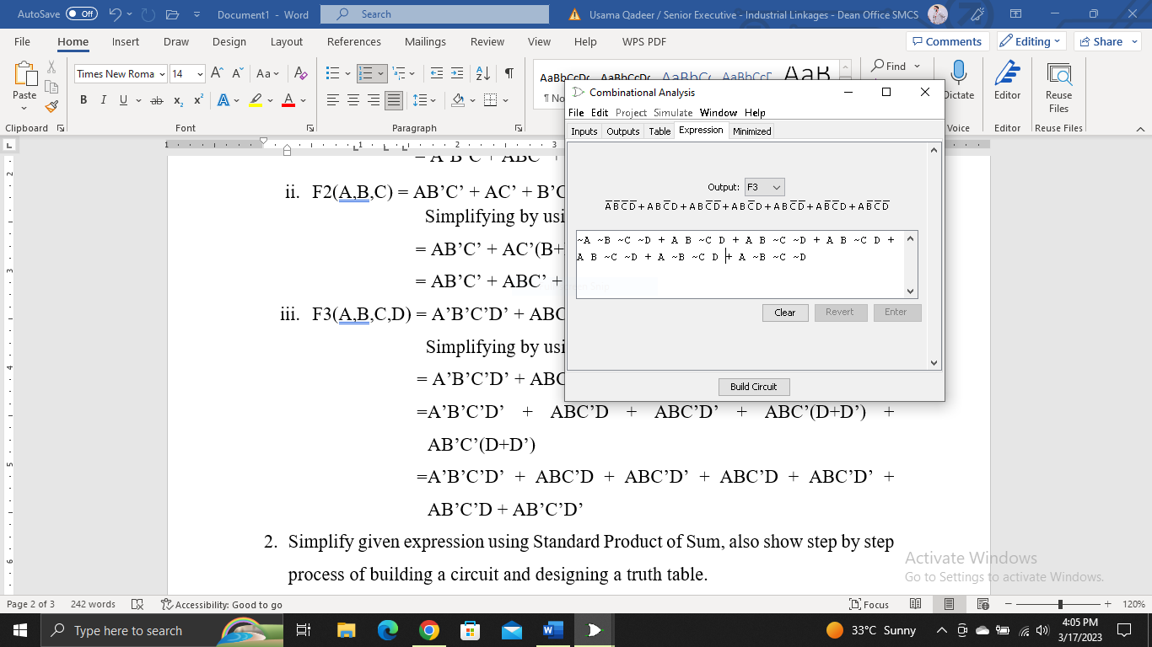

1. Simplify given expression using Standard Product of Sum, also show step by step process of building a circuit and designing a truth table.
2. F1(A,B,C) = (A’+B’+C ) ( B+C’) ( A+C’)

Simplifying by using POS

= (A’+B’+C) (B+C’+AA’) (A+C’+BB’)

= (A’+B’+C) (A+B+C’) (A’+B+C’) (A+B+C’) (A+B’+C’)

1. F2(A,B,C) = (A’+B’ ) ( A+C’) ( B+C’)

Simplifying by using POS

= (A’+B’+CC’) (A+C’+BB’) (AA’+B+C’)

= (A’+B’+C) (A’+B’+C’) (A+B+C’) (A+B’+C’) (A+B+C’) (A’+B+C’)

1. F1(A,B,C,D) = (A’+B’+C+D ) ( B+C’+D) ( A+C’)

Simplifying by using POS

= (A’+B’+C+D) (AA’+B+C’+D) (A+BB’+C’+DD’)

= (A’+B’+C+D) (A+B+C’+D) (A’+B+C’+D) (A+B+C’+D) (A+B’+C’+D) (A+B+C’+D’) (A+B’+C’+D’)

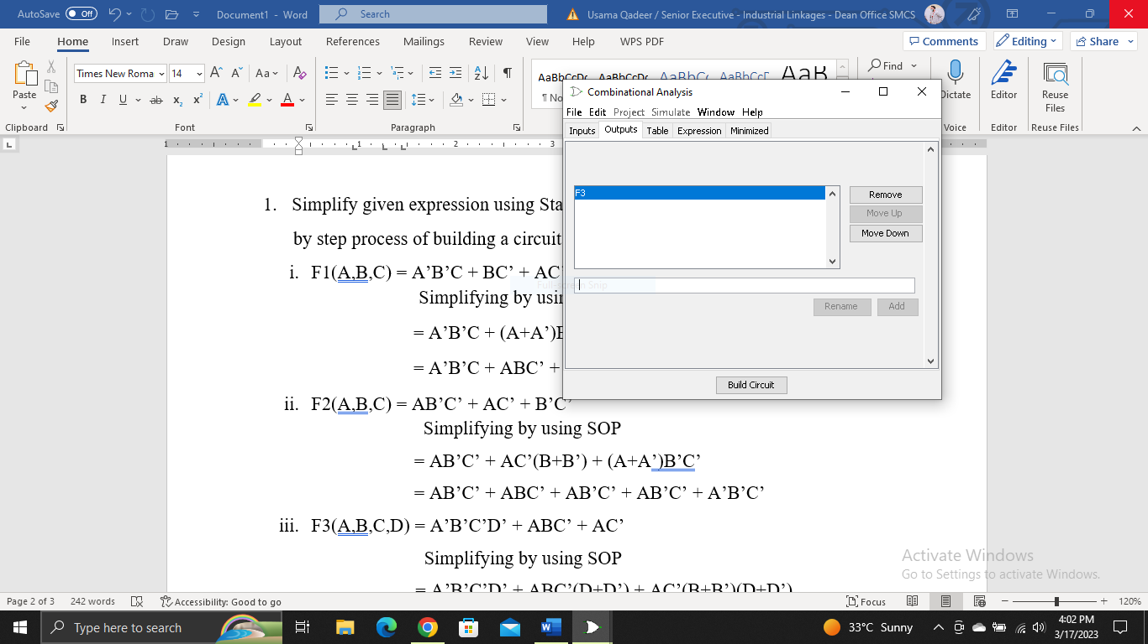

1. Why do we convert SOP & POS into their Canonical form?

* Standardization makes the evaluation, simplification, and implementation

of Boolean expressions much more systematic and easier.

* We Perform Sum of Product & Product of Sum for converting Truth

Table into Logical Expression.

1. What is Combinational Analysis?

A combinational analysis is a report that combines the results of multiple reports (criteria) into a single report. The way in which we combine these reports allow us to simulate joins in the data that otherwise don’t exist.

1. What are minterms and Maxterms?

* **Minterms:**

In a Boolean function, a product term in which all the variables appear is called a minterm of the function. Minterms specify the function as an OR of the minterms (product terms).

* **Maxterms:**

In a Boolean function, a sum term in which all the variables appear is called a maxterm of the function. Maxterms specify the function as an AND of the maxterms (product terms).